Dungeon-RPG Test Plan

1. After starting the game, you are brought to a start menu.

From this menu you can choose which character you want to be and what you want to name your Hero. You can toggle which image is shown in the middle. Press “Start Game” to start the game.

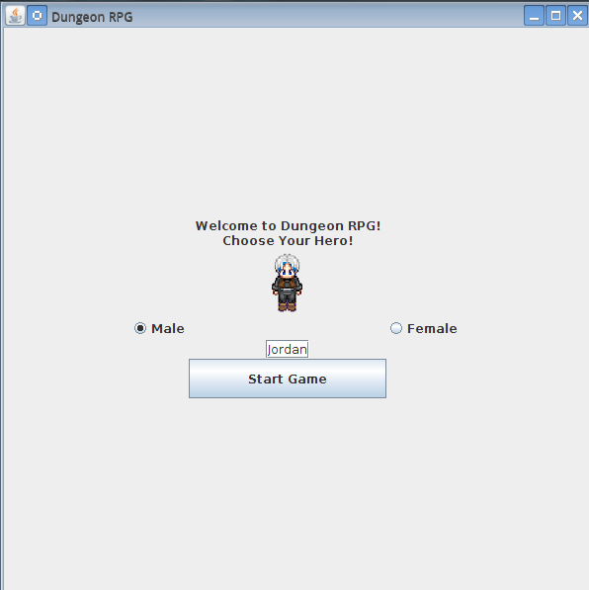

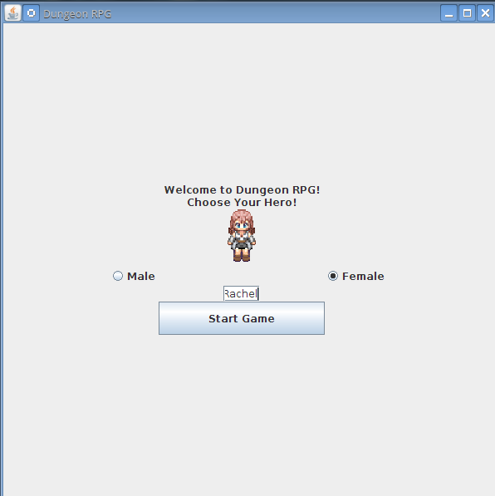

1. The Hero can move around the grass and into the cave entrance, but should not be able to move onto the rock parts of the cave, the water, or onto the trees.

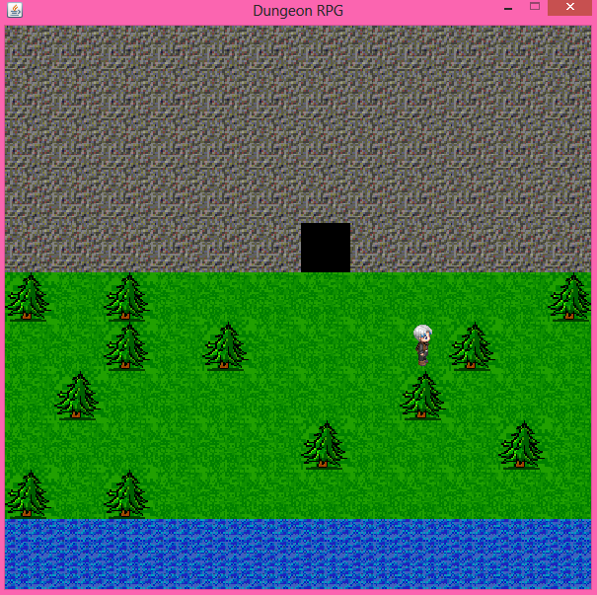

1. Use the arrow keys to move around. The black tiles indicate doorways to the next dungeon or back to the previous dungeon. Once the Hero enters the Dungeon, you have a chance to run into battle (roughly 10% chance for each step taken).

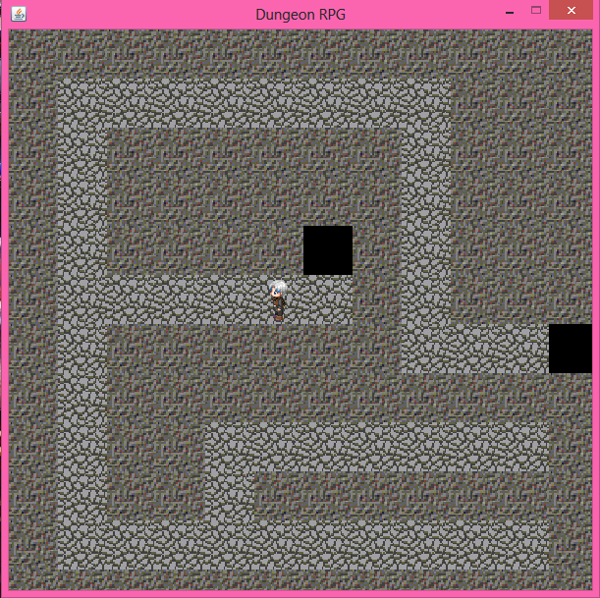

1. When you run into a monster, a prepare for battle screen appears.

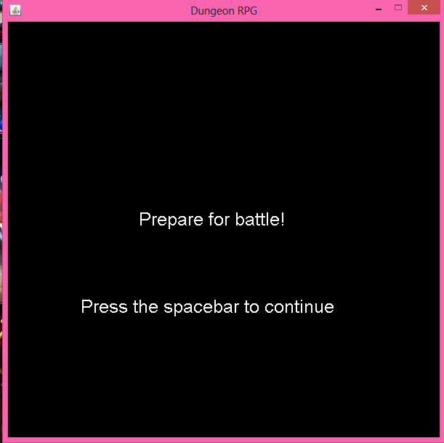

1. 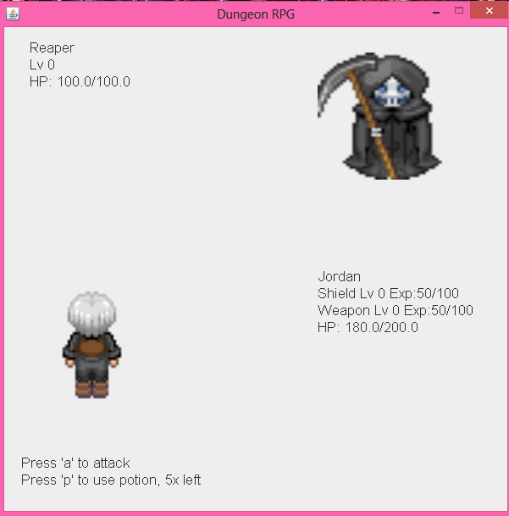Each attack or potion you use, the monster will attack once. An animation should happen after every attack and when the Hero uses a potion to heal. This is the battle screen. After each battle, your shield and weapon increases in experience. After entering into another battle, you should notice the shield and weapon experience going up.

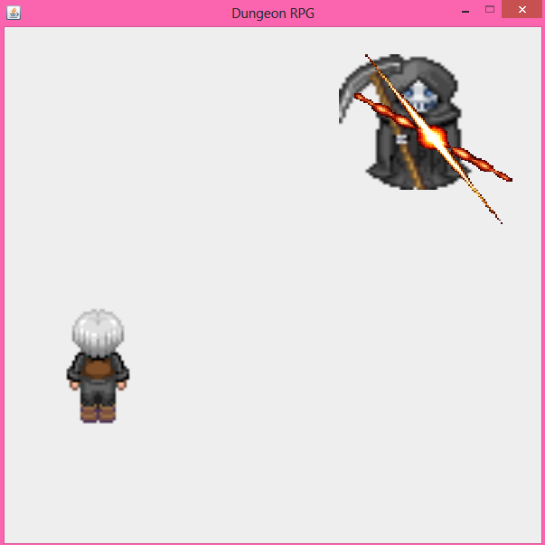

Attacking the monster animation

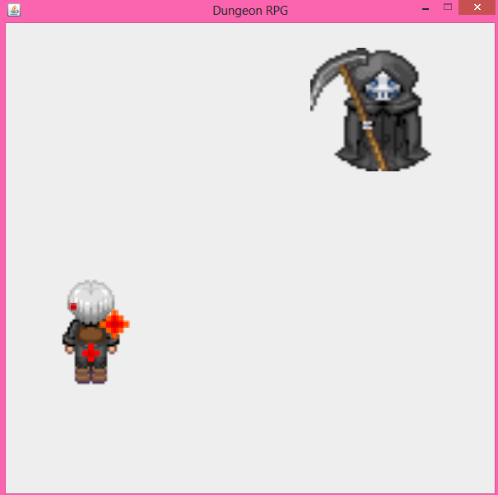

Using a potion animation

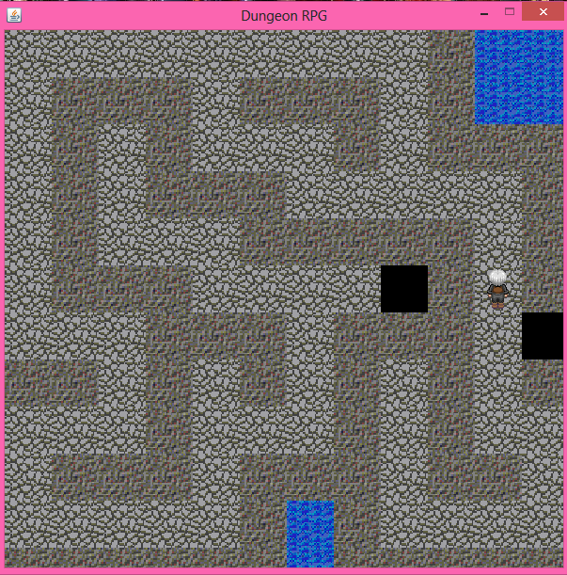

This is the next map. Monsters are higher level, stronger, and give more experience points.

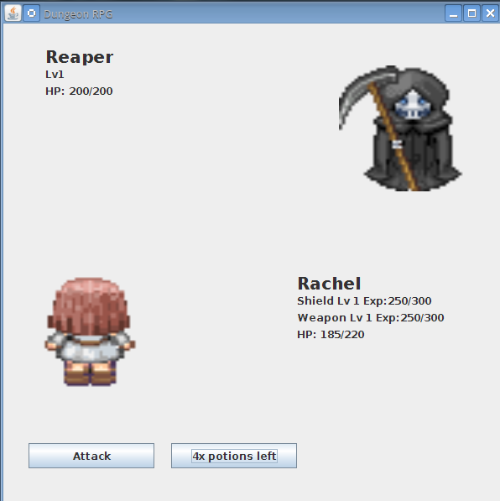Notice that because I killed a few monsters in the previous map, my shield and weapon leveled up, which caused my maximum hp to raise (shield), and now if you attack, you will notice that you also do more damage (weapon). Also, the required exp for both items are now higher. After using a potion, the potion count show lower by 1, and your hp should replenish.

1. If a monster kills you during battle, a new screen will appear.

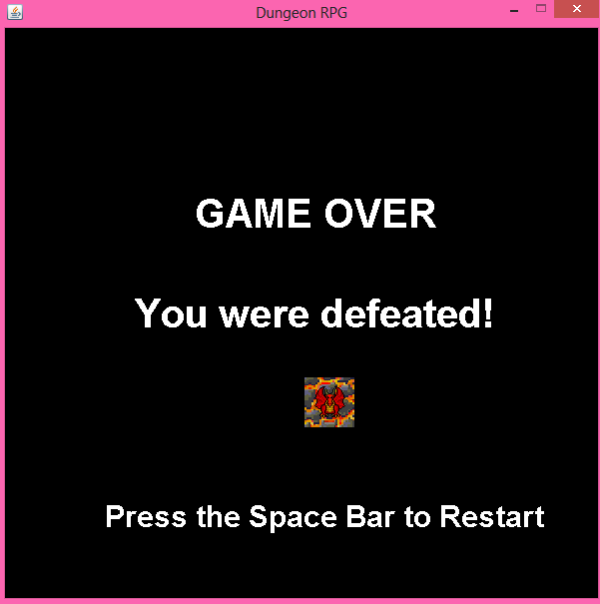

1. Pressing the space bar will return you back to the start menu.